# Exercise: Flexbox - Calendar

Create a web page like the following:

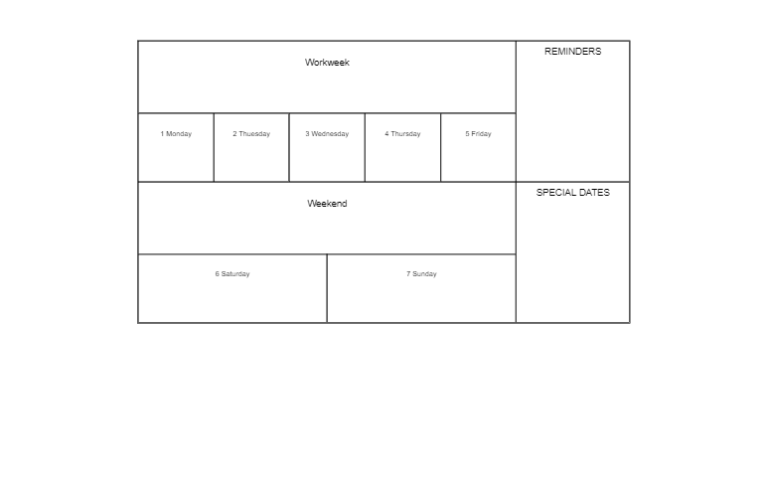

### Constraints

* Change the document title to "**Calendar**"
* Create a div with class container and two sections inside
  + First section has class week
  + Second section has class notes
* Use span tags for all content
* Change the div and sections display property to flex and align the items in **center**
* Set on the div max-width 65vw
* The span must have
  + Border width - 1px
  + Border color - black
  + Border style - solid
* For the section with class notes use the property flex-direction column
* Set on all HTML elements the property box-sizing: border-box